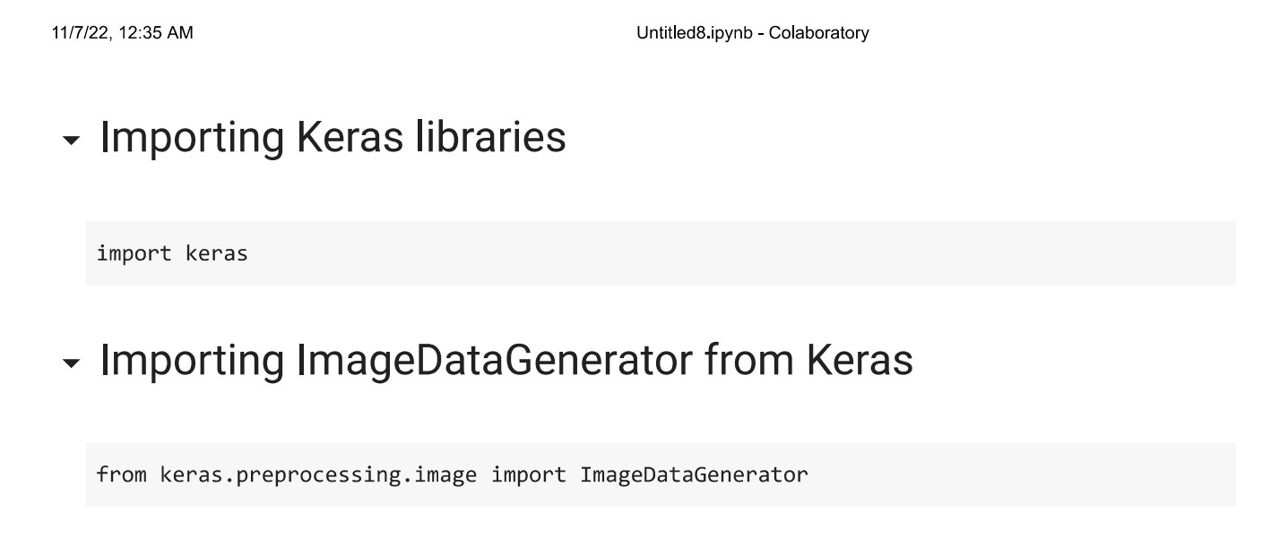
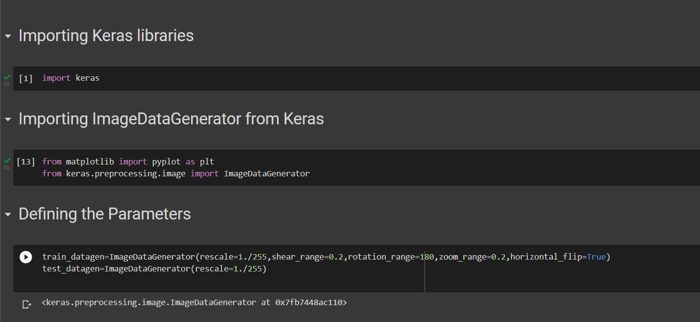
EARLY DETECTION OF FOREST FIRE USING DEEP LEARNING

MODEL BUILDING

SAVE THE MODEL

Team ID
PNT2022TMID03543
Project Name
Project-Early detection of forest fire using deep
learning

SAVE THE MODEL
Your model is to be saved for future purposes. This saved model also is integrated with an
android application or web application in order to predict something
.

IMPORT LIBRARIES:

IMPORT ImageDataGenerator FROM KERAS:

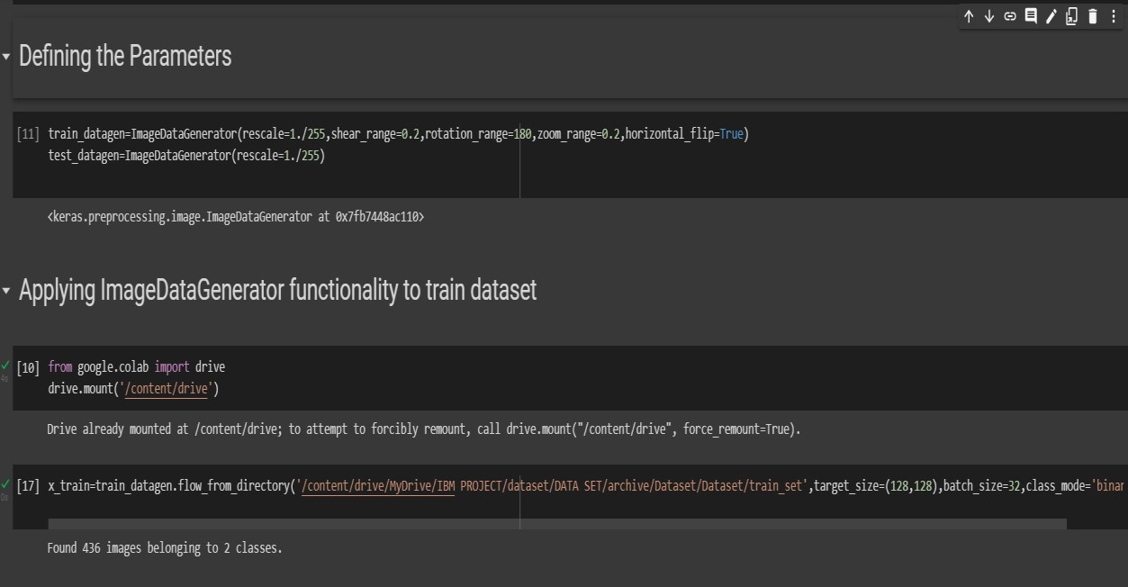
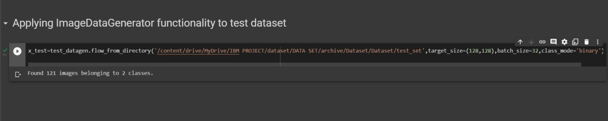
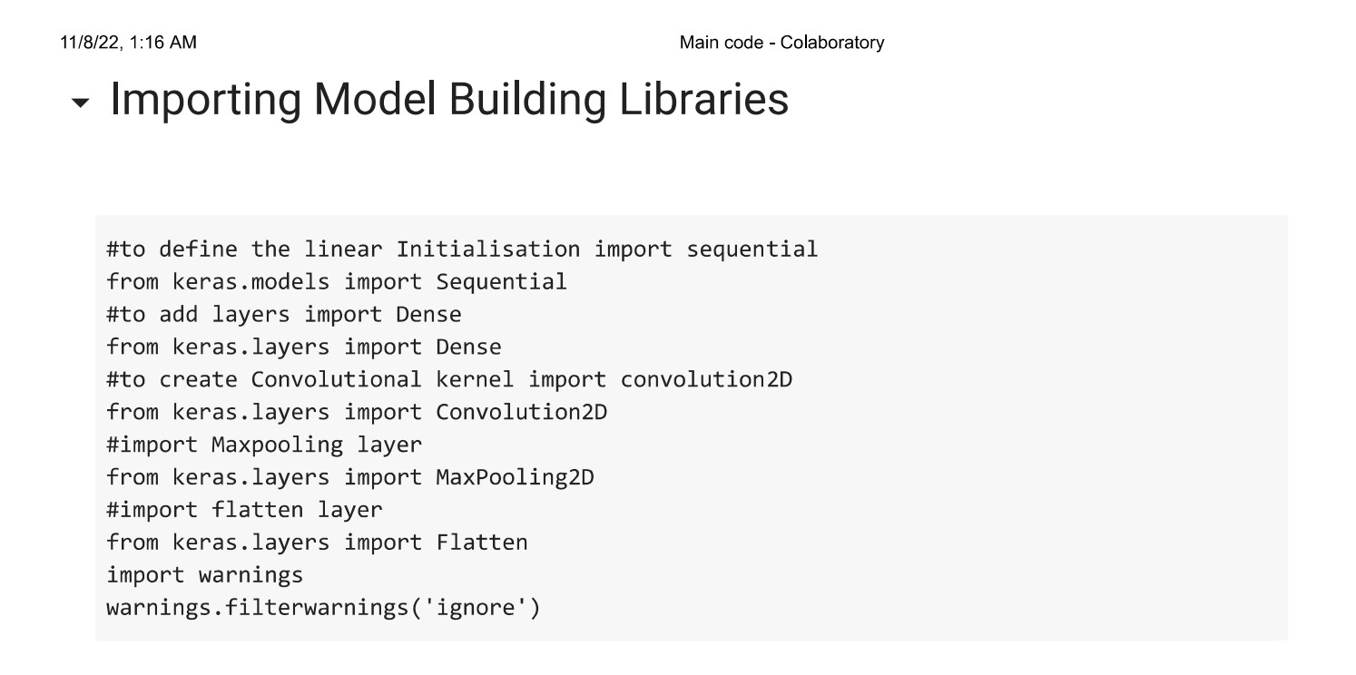
APPLYING ImageDataGenerator to train dataset:
ply
flow_from_directory ( )
methodfor Train folder.

APPLYING ImageDataGenerator to test dataset:
Applying the
flow_from_directory ( )
methodfortest folder.

IMPORTING MODEL BUILDING LIBRARIES:

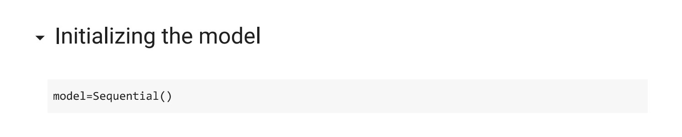
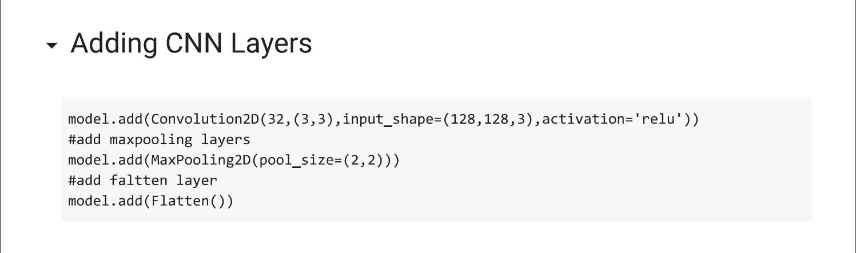
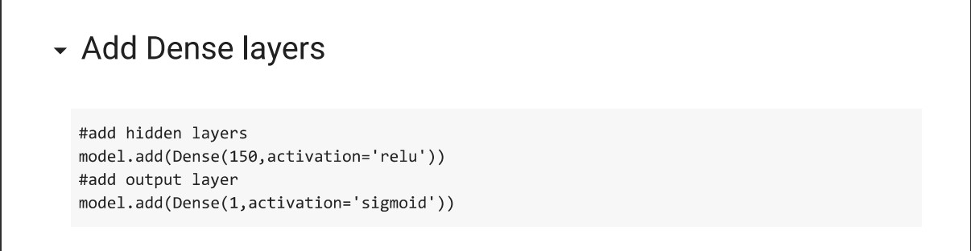
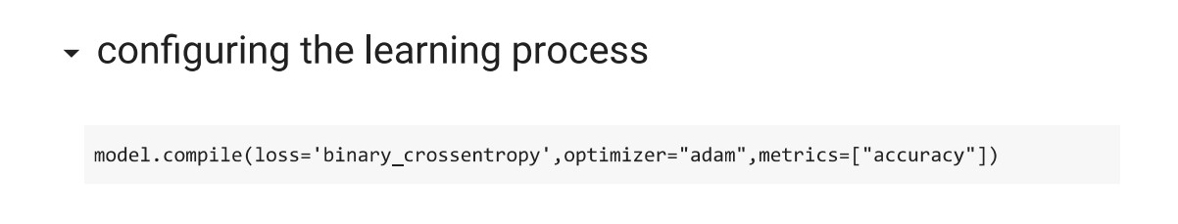
INITIALIZING THE MODEL:

ADDING CNN LAYERS:

ADDING DENSE LAYERS:

CONFIGURING THE LEARNING PROCESS:

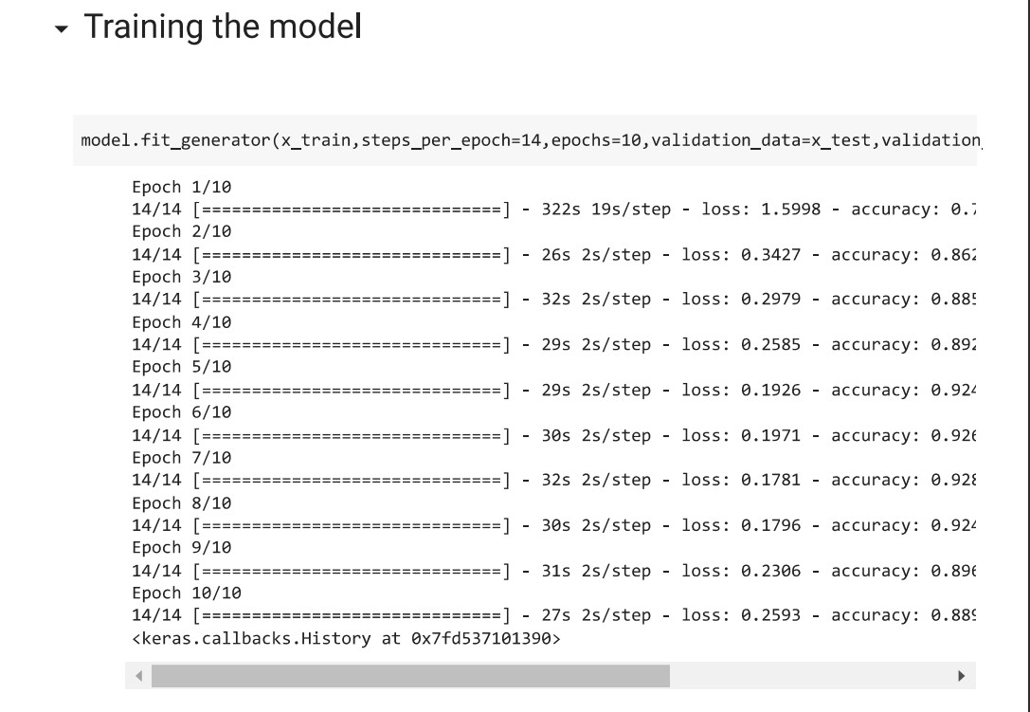
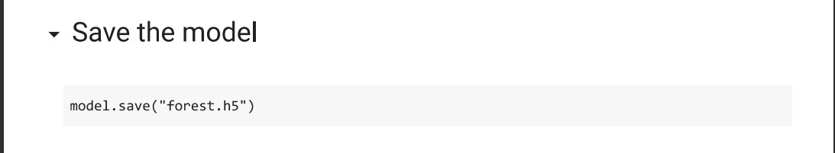
TRAINING THE MODEL:

SAVE THE MODEL:

